Caveman 2 Cosmos  
Version 33 (SVN

An Unofficial Community Expansion Pack

Civilization IV: Beyond the Sword 3.19

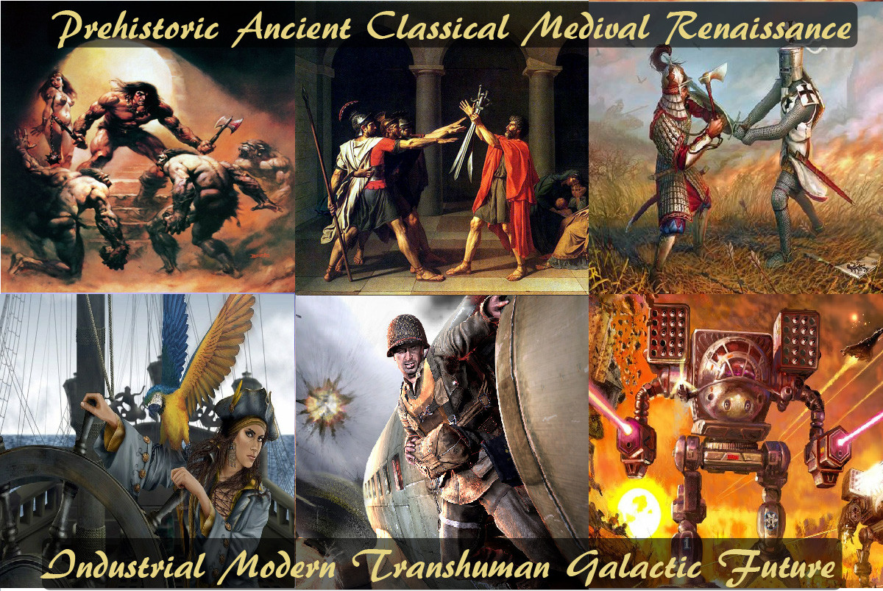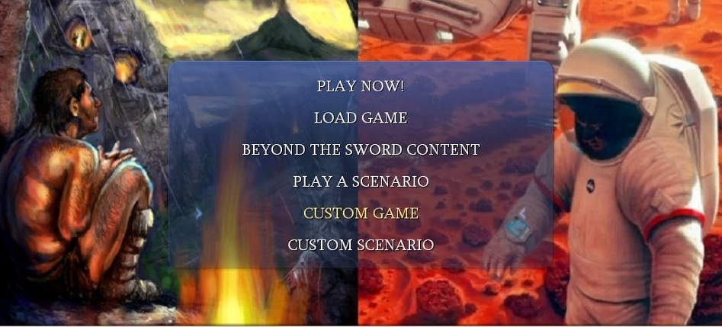

Caveman2Cosmos is a CivFanatics.com unofficial community expansion pack that add new features, techs, units, building’s, gameplay options, and other content to the Civilization 4 experience. It is the most expansive Civilization 4: BTS mod to date with almost daily updates since November 2010.   
  
It is the spiritual successor the Civilization 4 mod Rise of Mankind and its add-on A New Dawn, and combines the work of over 100+ CivFanatics.com past and present modders to create a mod to "rule them all". It is currently being developed by StrategyOnly Productions with a volunteer production team composed of prominent members of CivFanatics.com.

At A glance  
10 Eras  
734+ Technologies  
2700+ Buildings  
1200+ Units

Major Features  
 Many of the features of Caveman2Cosmos are the combined programming efforts of the community of CivFanatics.com, but a majority are original features exclusive to this unofficial expansion pack. Some of this features are can be turned on and off in the Custom Game Screen.

**1. Multiple Production**  
Multiple Production allows cities to produce more than one building or unit whenever possible. If a city has overflow production from the last item, it will be applied to the next item in the city queue. If the overflow production is enough to complete the next item, this process repeats. With large military cities, you can easily create multiple missiles or infantry units in one turn.  
 **2. Multiple Research**  
The same concept as Multiple Production. If you have enough overflow beakers from your last research project to complete the next technology in the queue, you will research multiple technologies in one turn.  
  
**3. Usable Mountains**  
Usable Mountains transforms peaks from wasted space to strategic chokepoints and useful industrial locations. Resources can and will spawn on peaks, and units will be able to move over peaks after you have researched Mountaineering. After researching Algebra, cities can be constructed on peaks. Peaks now give 3 production, but no food or commerce. Any improvements that can be built on hills can be built on peaks as well.  
  
There is a new promotion, Mountaineering, available to Great General units. With it, all the units in the group will be able to cross over peaks without the aid of the Mountaineering tech. Peaks offer units a 75% defense bonus, the largest in the game.  
  
**4. Fixed Cultural Borders**  
Fixed Cultural Borders completely changes the way borders worked. Instead of Culturally-Driven borders, Military force and might dictate the spread of borders. With Fixed Borders, Units have new command "claim territory" that you can apply in an enemy territory. You claim it, next turn the plot is inside your borders. In order to recapture it, enemy must place his forces on that plot and do the same ("claim territory").  
  
When capturing cities, you get all the territory that the city 'provides' to its original owner. So when you're at war with someone and capture all his cities, you will get ALL his territory, up to the last plot (there's only one exception to this rule - the tiles that are not 'provided' by cities, but claimed by force can remain in the old civ, but for sure they can't go to other neighboring civ that is neutral in war). In order to keep all this territory you need only the military force. No neighbor of his that is at peace with both sides can benefit from the war. If someone wants that territory – he must declare war and capture it or trade for it (city trading, like in normal game).  
  
During a war, if a tile has more of your tiles surrounding it than the enemys, it is claimed automatically, if no enemy units are defending it. This makes the borders less shredded at the end of war.  
  
If you are not using a civic that "forces" fixed borders, the game acts as before (i.e. the culture defines borders) and once a player has the necessary civics all of his territory becomes ‘fixed’, no one can take it by culture means anymore and his units get the new command to execute when in enemy territory (‘claim territory’). The player still culturally expands his borders over unoccupied territory and over nations that don’t have fixed borders (think of the Roman Empire that enforced its own borders, but influenced the surrounding tribes that had no solid state formed).  
  
**5. Surround and Destroy**  
Surround and Destroy gives attack bonuses for surrounding enemy forces. The more units you have around and enemy, the larger the bonus, up to the maximum of 60%. Particularly useful for sieging medieval cities.  
 **6. Advanced Diplomacy**  
Advanced Diplomacy vastly changes the way diplomacy works from standard Civilization. Many new trading options are added, each with their own benefits, and potential disadvantages.  
  
**7. Embassies**  
Nations can now establish embassies in other nations. Embassies improve diplomatic relations between countries, but be warned; revoking a foriegn embassies rights will have disastrous diplomatic repercussions with the other nation. Embassies also allow the trade of Military Units and Workers between countries. In addition, Embassies are now required to unlock higher diplomatic functions with other nations, namely, Open Borders Agreements and Defensive Pacts. Be warned, Embassies allow for enemy spies to more easily complete their missions in your country.  
  
**8. Right of Passage**  
When players research Writing, they can request to have a Right of Passage agreement between two civilizations. The agreement is similar to open borders, in that it allows foreign trade, but the agreement only allows for defensive units to pass through the nations. Offensive units will not be able to enter the territory.  
  
**9. Trading Military Units**  
Certain Military units, like siege machines can be traded, with Advanced Diplomacy. To be traded, each player must have an embassy in the other players nation. Each tradable unit will be marked in it's respective civilopedia entry with "This unit is tradable."  
  
**10. Trading Workers**  
Workers, can be traded, with Advanced Diplomacy. To be traded, each player must have an embassy in the other players nation  
  
**11. Buying and Selling of Corporations HQ's**  
Nations, if they happen to own a corporation Headquarter, can also sell it to other nations, where it will be automatically moved to one of their cities. If a nation does not own the particular Corporation Headquarter, they can offer to buy it from the owner.  
  
**12. Trading Contact with Other Civilizations**  
Nations can buy and sell contact with other civilizations that they have not yet met. It allows you to meet civilizations who you would not otherwise be able to trade with for many centuries.  
  
13. Barbarian GeneralsBarbarian Generals allows units to gain Great General experience from combat with Barbarians. It also allows barbarians to get experience as well, and they will be able to spawn their own Barbarian Great Generals.  
  
**14. Assimilation**  
When you capture an enemy city, it retains the personality of the former owner. The conquering player will be able to build the former owner's Unique Unit and Unique Buildings in that city instead of their own.  
  
**15. Ruthless AI**  
The ultimate challenge. Ruthless AI removes any human aspects from the AI, making them cold, calculating, and cunning. The AI will expand strategically into nearby targets, destroy threats, and use diplomacy to it's advantage. Watch small border conflicts flare up into International conflicts, with the entire world arrayed against you.  
  
**16. Great Commanders**  
Great Commanders are a new use of Great Generals. While players will still be able to attach Generals to units or settle them in cities, they will also be able to use the general unit in stacks, and have Great Generals receive XP from successful combat in nearby tiles. Great Generals will be able to earn promotions from this XP, and the promotions will boost the stats of all nearby units. Other promotions can extend the command range of the general (the radius in which the general's effects may be felt) or the amount of effects the promotions provide.  
  
**17. Realistic Culture Spread**  
Culture will spread in a more realistic fashion, more quickly over low lying lands, like plains and grasslands, and slower over heavily forested hills and peaks.  
  
**18. Guilds**  
Guilds are a medieval variant of corporations. There are twelve total guilds, part of three separate branches, the Servant Guilds, the Victualers Guilds, and the Craft Guilds. Each of the twelve guilds offers separate benefits to cities that incorporate them, be it health, happiness, production, science, or wealth. Spreading guilds is identical to spreading corporations, except it doesn't cost money. Guilds will, however, incur maintenance fees; the best way to alleviate these fees is to use the "Guilds" economic civic. Guilds are very useful for increasing city production or making your cities happy and healthy. Most guilds become obsolete in the Industrial Era.  
  
**19. Modern Corporations**  
Modern Corporations expands the amount of Corporations in the late game. Corporations that give increased military training and experience are useful for catch-up. Other corporations can give happiness, health, culture, science, commerce, or espionage against rivals.  
  
**20. Advanced Nukes**  
Advanced Nukes expands the nuclear arsenal available to players, allowing players to access advanced biological weapons, and nuclear weapons that can destroy entire continents. Chemical and Germ warfare can be used, to ruin even coastal land, and utterly annihilate a city to nothing. Advanced Nukes provides the finest and latest gear in the art of destruction.  
 **21. Mastery Victory**  
  
Mastery Victory is the ultimate victory condition. Players must survive to the end of time, and be the most powerful player. Having cities with legendary culture, or constructing wonders adds to your final score. Spreading your religion to the most cities also boosts your score. The player with the highest score at the end of time wins.  
  
**22. Resource Depletion**  
Resource Depletion allows for heavily used non-renewable resources to deplete from the the game. Each turn, the game measure how much you are using a resource, and based on your usage, the chance of depletion changes. As you rely more and more on a particular resource, the odds of it depleting increase.  
  
In Addition to this, mines without any resource also have a small chance of depleting. When a mine depletes, no mines can be built on top of the tile ever again. While this will rarely happen in the early game, by the late game, players will be forced to re-adjust their strategies if they relied too heavily on mines for their production.  
  
To balance this, Players with Resource Depletion installed will also have an increased chance of discovering resources.  
  
**23. Terraforming**  
After researching Weather Control, players may terraform prevoiusly inhospital land into lush grasslands. Workers gain the ability to terraform, and can turn land to plains, and eventually, into grasslands. This will allow your cities to grow even larger, as your civilization reaches it's own "Golden Age."  
  
**24. Sea Tunnels**  
After researching Civil Engineering, players may build underwater tunnels to join continents together. These tunnels allow units to move under the water, and reach areas prevoiusly only accessable by ship. Be wary though, a sea tunnel can just as easily be used to allow enemy troops easy access to your mainland cities, bypassing your naval defenses.  
  
**25. Mega Cities**  
Player cities can now expand to a third level radius, if enabled. After a city reaches an "Influential" level of culture, it's third ring of tiles will become workable, allowing for mega-cities to emerge. Players can use this expanded access to food to fuel thier specialist economy, drive their war machine, or to gain access to prevously locked resources. However, because the third ring of culture is now workable, this change makes maintaining your cultural borders more important. Losing access to some outer-ring mines may become the difference to defeat or failure in a war. In addition, players will face other new challenges. Because cities will reach much higher levels of population before running out of food, unhealthy and unhappy cities may become problematic. If poorly maintained, these larger cities may even decide to revel against your leadership. Players should spend extra effort to keep these mega-cities healthy and happy.  
 **26.Great Commanders**  
Great Commanders are a new use for Great Generals. Previously, players could only settle Great Generals in cities for XP, or attach them to a unit and give the unit immediate XP. Great Commanders give Great Generals a third ability, the ability to help lead troops in battle. While initially providing no benefit, a Great Commander will gain XP from successful combat on the same tile as other friendly units. When the Great Commander levels up, it will be able to choose promotions from a special promotion tree designed specifically for it's use. The promotions don't help the Great Commander, nor can the Great Commander partake in any combat, but they will help nearby units. Units that are inside of the Commanders command range will receive the effects of the promotion, allowing for much more powerful armies on the battlefield, for offense and defense.  
 **27.Occasional Promotions**  
Occasional Promotions is a new way for units to receive promotions. In every battle, a unit has a chance of earning a promotion that they are eligible for, after combat is resolved. This chance is not purely random, it is affected by the chance of success in combat, and how well they preformed. If a unit had a high chance of victory, the odds of being promoted in battle is low, but if the chances were slim, and it overcame the odds, the chance of being promoted is much higher. Likewise, if a unit preformed well in battle, and lost little or no health, the chances of being promoted increases. If the unit barely survived, the chances of being promoted decreases. If a unit is promoted in battle, it will not earn any XP for that battle.  
 **28.Realistic Corporations**  
Realistic Corporations gives freedom to Corporations, as they are no longer state-controlled entities. While the State may own the city a corporation operates in, or the headquarters for the corporation, they can not control it's spread, except in extreme circumstances. No Executives or units that can spread corporations can be trained, except when using a civic that blocks foreign corporations. Corporations are no longer founded by units, buildings, or otherwise. Instead they are founded by a little bit of luck, and some strategy.  
 **29. Ruthless AI Game Option**  
The Ruthless AI Gameoption will make the AI much more manipulative and harder to beat than normal or Aggressive AI. The AI will use techs and gold to hire war allies, often sparking small border disputes into raging world wars that ultimately will work to their advantage. Expect to be sneak attacked, or worse, blitzed, as the AI siezes poorly defended border cities, and gobbles up smaller city-states. The AI will remember your breaches of trust more keenly; it may be wiser to die an honorable death then become the next Benedict Arnold. Lastly; suspect every AI request; an ordinary map request may actually be a search for future attack sites, so be prepared for pre-emptive strikes.  
  
**30. Dynamic XP**  
Unit XP is now saved in fractional values, and units gain experience dynamically, depending on their battle success and the odds. The less likely a unit will win a battle, the more XP it will receive, to a maximum of 6XP attacking or 3XP defending. Units will always receive a minimum of 0.25XP. In battle, the less health the units lose, the more XP the units can earn, so that players are forced to make more strategic attacks, and that players can no longer gain significant amounts of XP by attacking very weak units.  
  
**31. Castle Improvements**  
Castle Improvements adds a new system of improvements, making castles a key defensive structure.he Moat, Balistraria, Castle Turret, Catacombs,The Keep, Heavy Gate, Herbalist, Dungeon, and more.  
  
**32. Realistic Culture Speed**  
Realistic Culture Spread creates a more natural style of cultural spread from your cities. Culture spreads more slowly over rivers, higher terrain like hills and peaks, heavily wooded areas, and ocean tiles. Because this more natural spread also has the effect of limiting your cultural borders, three new intermediate culture levels have been added for this game option only, to expand your borders farther.  
  
**33. Advanced Espionage**  
Advanced Espionage adds a slew of new espionage missions for your spies to preform and cause havoc with. Also, Advanced Espionage scales all missions damage with game speed, so the effects of the missions are more pronounced on slower speeds, and less noticeable on faster speeds.  
  
**34. Employed Citizens**  
Certain Buildings employ your citizens. Your citizens will work in the building, ensuring it stays open, instead of working land or acting as a specialist. You can see how many citizens are employed by your city's buildings by viewing the employment dropdown inside of the city interface, (to the right of the city name). If your city lacks the population to staff all of the buildings, they will shut down until your city regains a large enough population to be operated again.  
  
**35. Subdue Animals**  
The Subdue Animals changes some of the mechanics of combat with animal units. Now when an animal unit is defeated instead of just being killed, it may be butchered for food and production, converted into a resource on the map or subdued as a captured version of the animal unit. Captured animals can be used to build special buildings. These buildings may provide resource, science, culture, happiness or reduce revolutionary sentiment. Some also allow new units or provide experience for units built in the city.  
  
**36. Crime and Punishment**  
Crime is used to represent the idea that humans are selfish and that they will commit offenses against others if they think they will get away with it. The fact that there is as much evidence for this selfish idea as against suggest that things are much more complex in the real world, but this is just a game. The higher the crime level in a city the more crimes, represented by "free" buildings, you will have. It will also allow you to build crime related buildings which can give you more money and units. Crime can be fought in two ways. Crime prevention buildings and crime fighting units. Both affect the amount that crime changes.  
 **37. Flammability**  
The concept of Flammability is introduced. Highly flammable building such as an Oil Power Plant, Oil Refinery, Chemical Plant, etc would generate have a large amount of "flammability" while a fires station, fire brigade, Artesian well, etc would lower the cities flammability.  
If it got too high then it would increase the risk of a fire. If a fire occurs then building will be destroyed. In other words you could control how frequent those random fire disaster events occurred.  
  
**38. Housing**  
In Caveman2Cosmos houses and residential buildings increase of decrease food, health, gold, and other bonuses depending on the Density of and wealth of the housing building. Density levels include Low, Medium, High, and Super Density and increase as Eras go by and are categorized by Low, Medium, or High Wealth of the building.  
  
Example:  
Trans-Human Era / Galactic Era  
- Low Density | Low Wealth = Dugouts  
- Low Density | Medium Wealth = Smart Homes  
- Low Density | High Wealth = Chateau  
- Medium Density | Low Wealth = Modular Highrise  
- Medium Density | Medium Wealth = Modular Homes  
- Medium Density | High Wealth = High-tech Manor  
- High Density | Low Wealth = Refugee Camps  
- High Density | Medium Wealth = Time Shares  
- High Density | High Wealth = Holochambers  
- Super Density | Low Wealth = Arcology Slums  
- Super Density | Medium Wealth = Arcology Suburbs  
  
**39. Hero System**  
Heroes can create exclusive Achievement Buildings and a new system for units is introduced.  
  
Hero Units  
- World Unit  
- Only one can exist and once it dies it cannot come back.  
- Can get a series of Hero promotions  
- Example: Spartacus  
  
National Units  
- National Unit  
- Limited amount of units per civ.  
- Gets normal promotions.  
- Example: Assassin  
  
Normal Units  
- Available to all civs.  
- Can make unlimited amounts of these units.  
- Gets normal promotions.  
- Example: Axeman  
  
Elite Units  
- National Unit  
- Limit 15 (can be rebuilt if they die)  
- Can get special elite promotions (not the same as heroic).  
- Example: Samurai  
  
**40 . Bug and BAT Options**  
BUG stands for BTS Unaltered Gameplay and is a collection of interface enhancements and screens that provide quicker access to information available elsewhere in the game plus some cool features that make playing the game a lot more fun by removing some of the tedium involved in micromanagement. This is our commitment to the player that no game rules are changed and no information not available somewhere in the original BTS interface is ever shown. BULL stands for BUg dLL and adds a lot of useful information to some of the hover texts, specifically the City Bar hover and the Yield and Commerce hovers in the City Screen.  
  
  
**41. Alternative Timelines**  
This adds historical fiction to fiction history to the Tech Tree and different flavors of "punk" including Megafuana Domestication, Clockpunk, Steampunk, Dieselpunk, Atompunk, Biopunk and Cyberpunk. Some sections are currently being developed. They each take up one (1) Tech slot on the Tech Tree and provide unique units, buildings, and wonders.  
  
-Megafuana Domestication is based on the late prehistoric period and fictionalizes if man could have ridden large animals like bears and bison.  
-Clockpunk is based on the technology used is based on springs and clockwork, and is usually set during the Renaissance.  
-Steampunk is set in the late eighteenth through the whole of the nineteenth centuries ending about 1919, and focuses on steam power and the possibilities it could bring.  
-Dieselpunk is based on the aesthetics of the period between the end of the World War i and the beginning of WW2.  
-Atompunk relates to the pre-digital period of 1945-1965, and the rise of the US military/industrial powers.  
-Biopunk focuses on near-future unintended consequences of the biotechnology revolution following the discovery of recombinant DNA.  
-Cyberpunk plots often center on a conflict among hackers, artificial intelligences, and megacorporations, and tend to be set in a near-future Earth.  
  
**42. Divine Prophets**  
Choose where to found your Holy Cities, and Divine Prophets provide bonuses.